Autopsy Report

Forensics Biology
Medical Examiners Office

Philadelphia, PA 19130

NAME: AUTOPSY NO:

AGE: DATE:

SEX: TIME:

PROCESCUTOR: MEDICAL EXAMINER:
ASSITANT:

ANATOMICAL FINDINGS:

CAUSE OF DEATH:

MANNER OF DEATH:

___________________________________________ _______________________
COMPLETED BY DATE

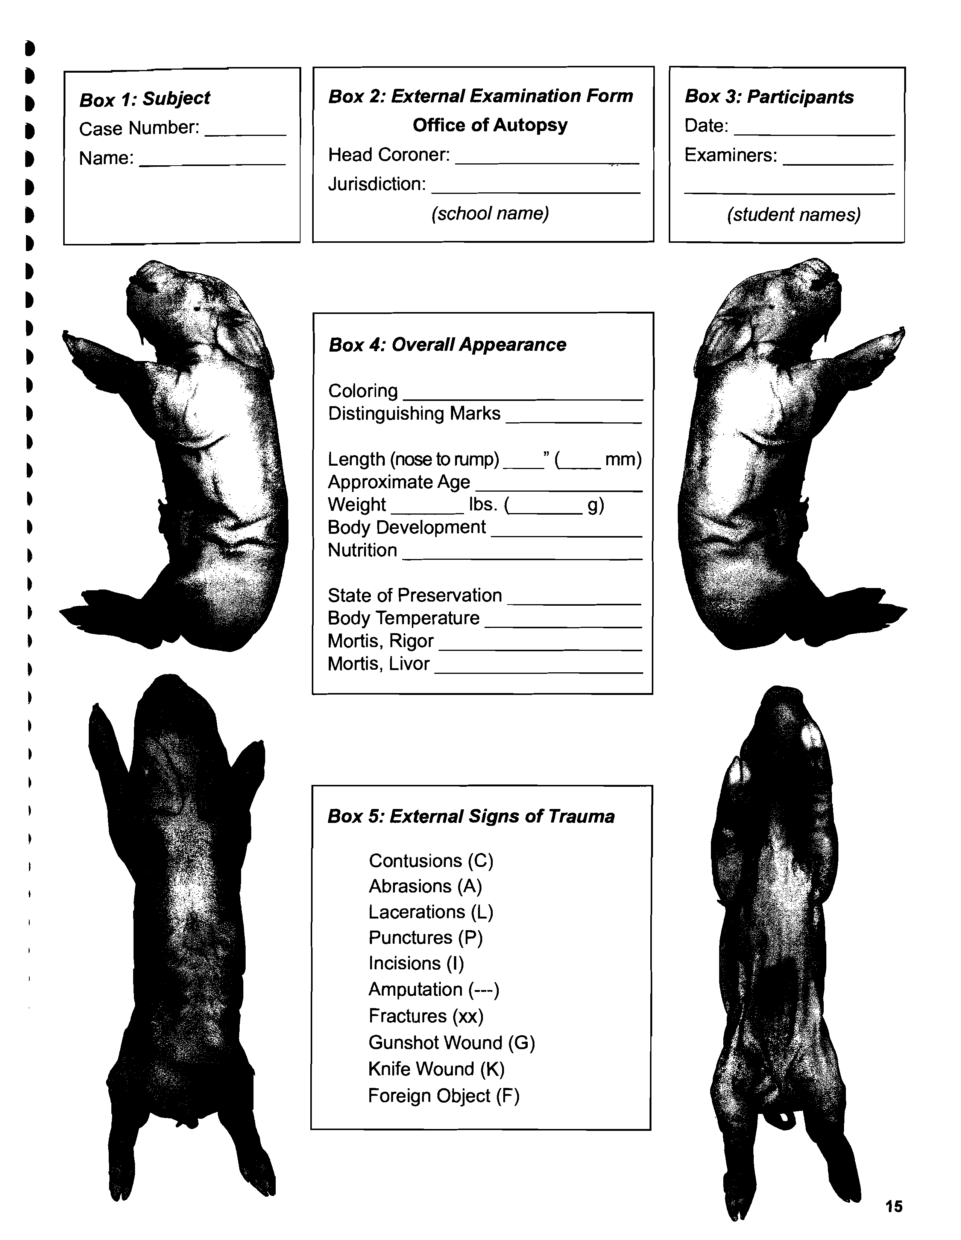
CIRCUMSTANCIAL SUMMARY

DOCUMENTS AND EVIDENCE EXAMINED

IDENTIFICATION

CLOTHING AND VALUABLES

EXTERNAL EXAMINATION

SIGNS OF DEATH

ARTIFACTS AND INJURIES

INTERNAL EXAMINATION

SEROUS MEMBRANES:

NECK ORGANS:

HEART:

VASCULAR SYSTEM:

LUNGS:

LIVER:

PANCREAS:

GASTROINTESTINAL ORGANS:

SPLEEN:

ADRENAL GLANDS:

URINARY TRACT:

REPRODUCTIVE SYSTEM:

CENTRAL NERVOUS SYSTEM:

PHOTOGRAPHS (Please attach any relevant photographs to report)

SPECIMEN FOR FIREARM EXAMINATION OR TRACE EVIDENCE:

SPECIMEN FOR TOXICOLOGY ANALYSIS:

SPECIMEN FOR CHEMICAL ANALYSIS:

SPECIMEN FOR CULTURE:

MICROSCOPIC EXAMINATION

